**Q1.**

1. **– (c)**

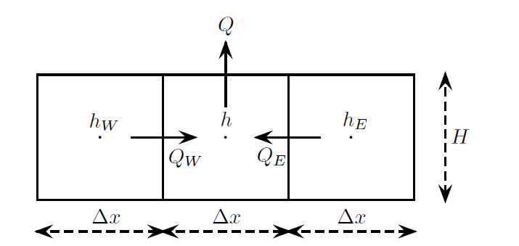

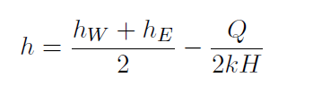

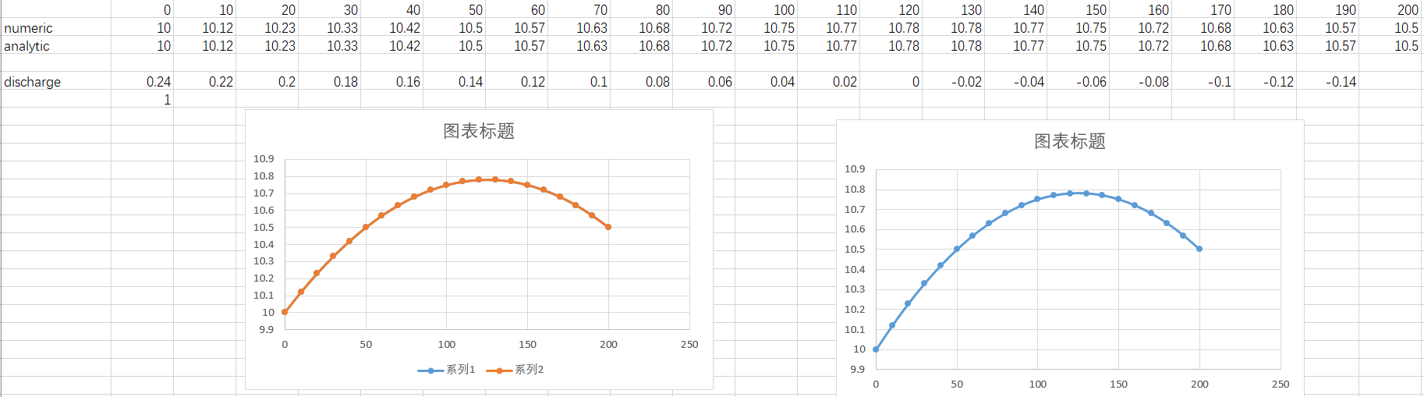

The solutions of analytical and numerical are exactly the same. And for discharge, the left boundary plus right boundary is 0.38 while the external discharge (infiltration) is 0.4. the reason for this can be explained by grid generation because we established our squares right at the center of the water depth but the discharge measured at the boundary so that one cell is missed after summing up all the infiltrations.

**(d) – (e)**

With heterogeneous infiltration value along the channel, we can deduce the formula below:

$$h=\frac{N_{1}}{2T}x^{2}+\left(\frac{h_{2}-h_{1}}{L}+\frac{3N_{1}}{8T}L+\frac{N_{2}}{8T}L\right)x+h_{1} x<L/2$$

$$h=\frac{N_{2}}{2T}x^{2}+\left(\frac{h_{2}-h_{1}}{L}-\frac{N_{1}}{8T}L+\frac{5N_{2}}{8T}L\right)x+h_{1}-\frac{N_{2}}{8T}L+\frac{N_{1}}{8T}L x>L/2$$

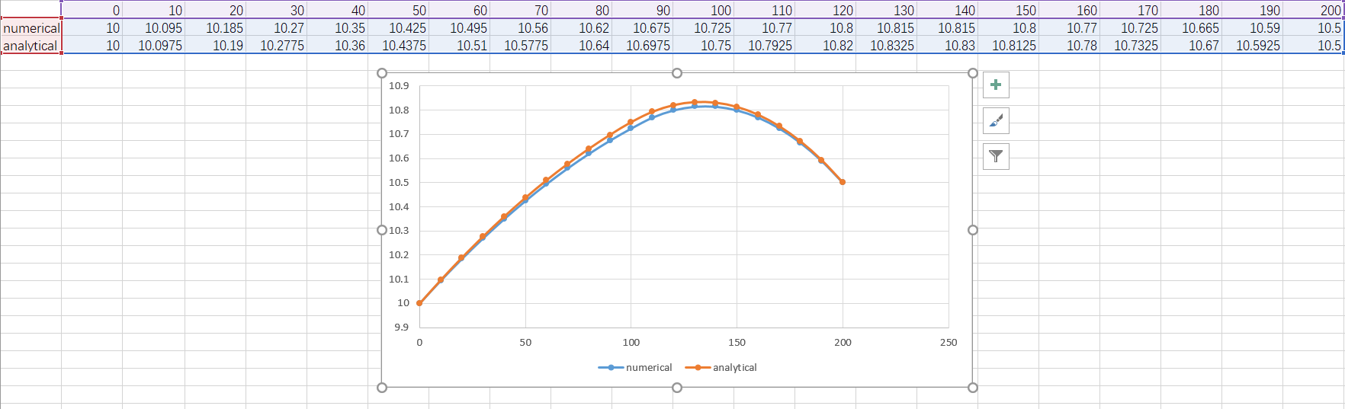

Q2: with leaky layer

1. Consider the leaky process as infiltration, and then we can derive 1 dimensional finite difference equation.

Inside each cell, we have

$$h=\frac{T\left(h_{E}+h_{W}\right)+∆x^{2}/c×{h_{1}}^{*}}{2T+∆x^{2}/c} x<0$$

$$h=\frac{T\left(h_{E}+h_{W}\right)+∆x^{2}/c×{h_{2}}^{*}}{2T+∆x^{2}/c} x>0$$

1. Numerical solution and analytical solution are almost the same expect for a little shift.

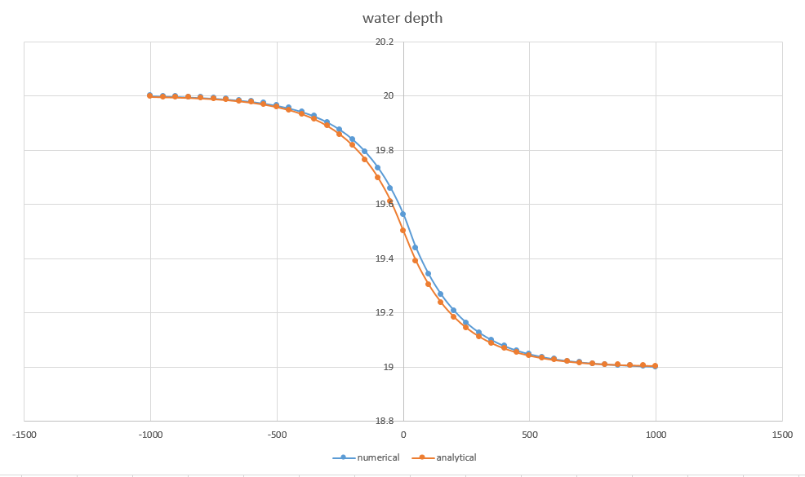

1. Discharge comparison

Found out that, they are almost the same, that proves our approach.

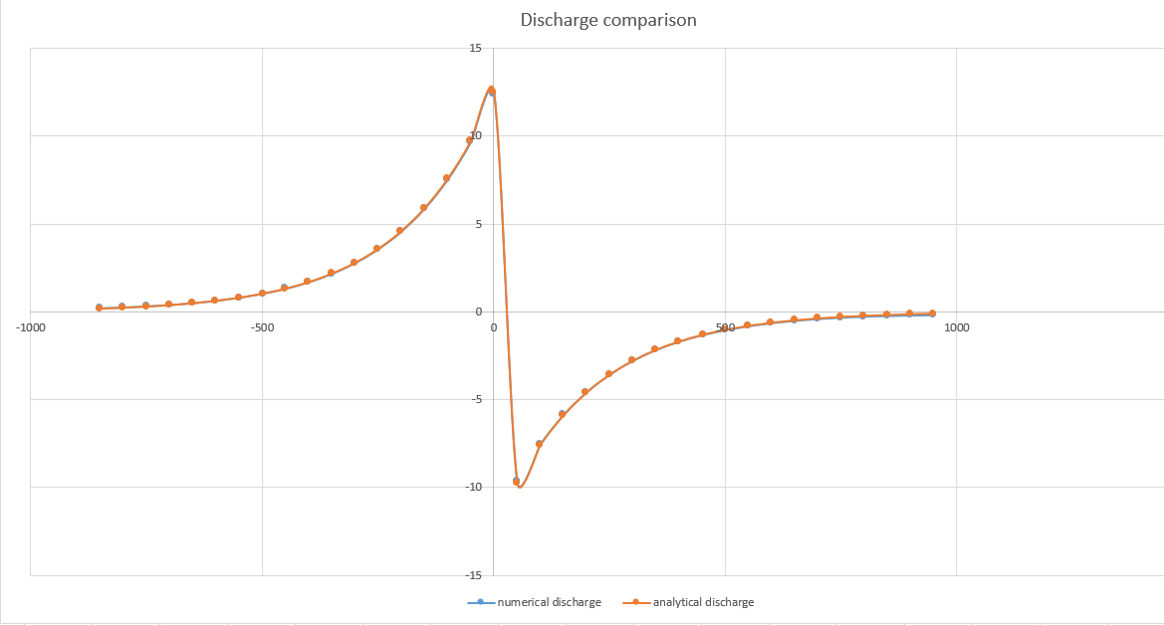

**Q3 transient flow**

With implicit method, the water depth at x=50m t=10 day is 10.2681 m and at t=20 day is 10.4298 m

Comparing to exact solution 10.26355 m at 10 day and 10.4292 at 20 day, the relative error is negligible.

After 10 days of dropping water level to 10 meters again, the water level at x=50 meters is 10.24743 meters

Comparing to exact solution, 10.23155 meters.

Q4.

